**Password Generator using Java**

These days, almost every website requires you to generate a temporary password. If a user forgets their password, the system will generate a random password that complies with the company's password policy.



In most cases, when you forget your password and select the "Forgot Password" option, you will immediately receive a new password at your registered email id or phone number. Log in to our account. And I get a different password each time. You may access your bank account while shopping at an online store or in many other ways. To confirm transactions from your bank account, send an OTP (One Time Password) to your registered phone number. or our email id, immediately.

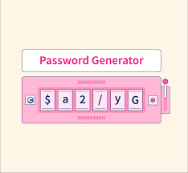

The following example generates a random password that satisfies the following conditions :

* must contain at least one uppercase letter.
* Must contain at least one lowercase letter.
* Must contain at least one digit.
* Length is 8 characters.
* Must contain one of the following special characters: @, $, #, !.

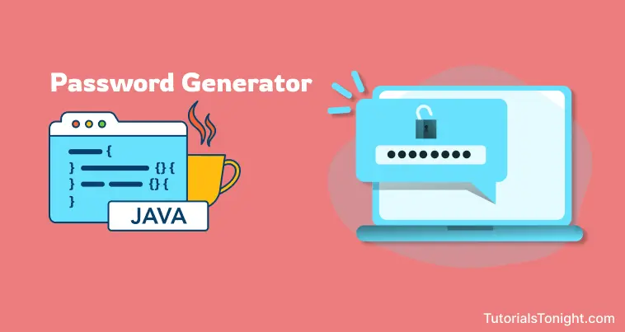

**Need to generate random passwords?**

Yes, it's important to have unique passwords for all your online accounts. When passwords are saved due to a security breach, hackers often store them in leaked password databases. Prevent your personal information from being exposed on the dark web with the Avast Random Password Generator.

**SCREEN: 1**

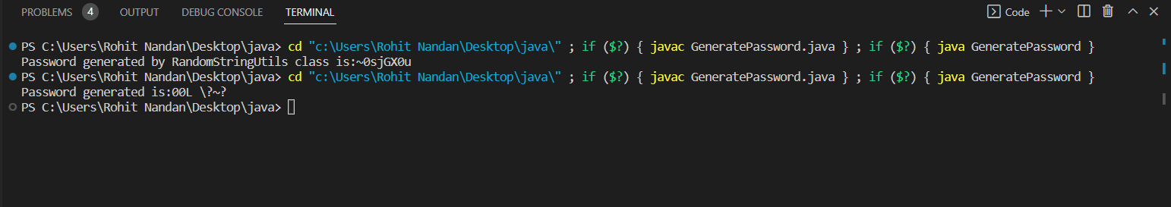

**SCREEN: 2**

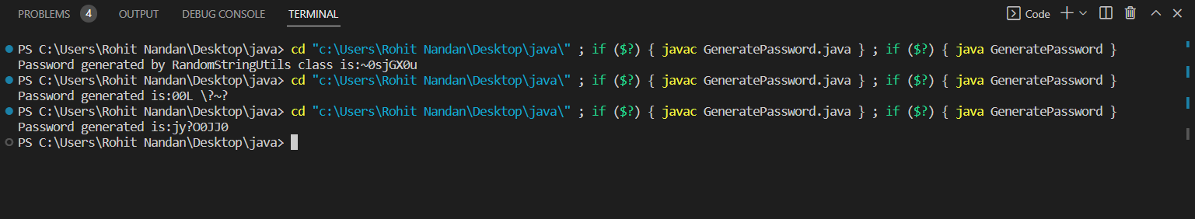

**SCREEN: 3**

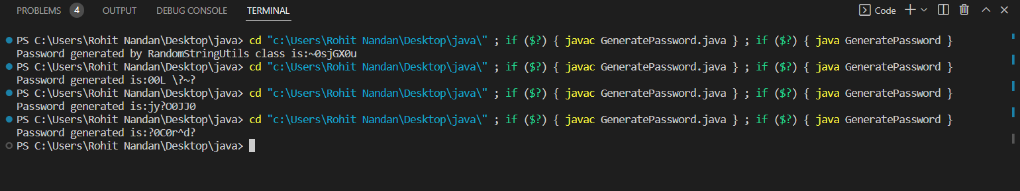

**SCREEN: 4**

